Screen capture of Suspect Drive 01 contents.

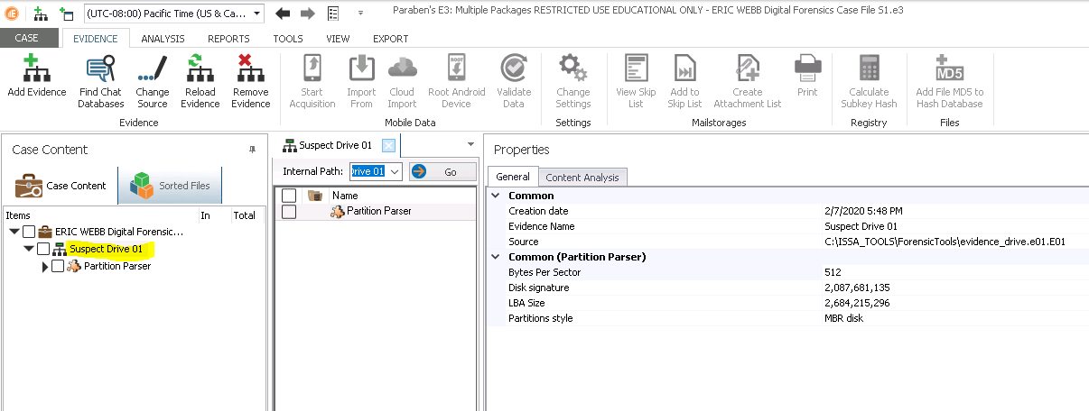

Total number of sorted files and list of contents.

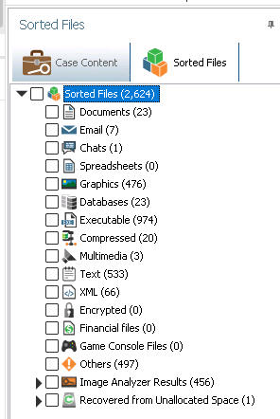

Suspicious and clean files. (110 and 19)

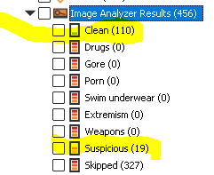

List of suspicious files.

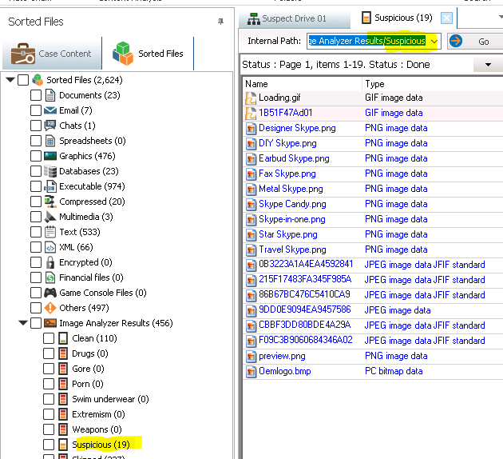

List of suspicious and clean from unallocated space. (0 and 0)

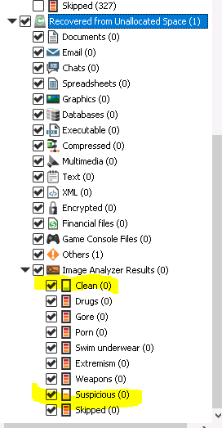

Common Log timestamp

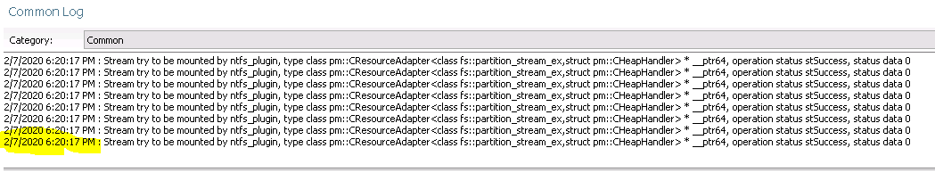



It stored them all in folders by categories rather than in there raw original format.

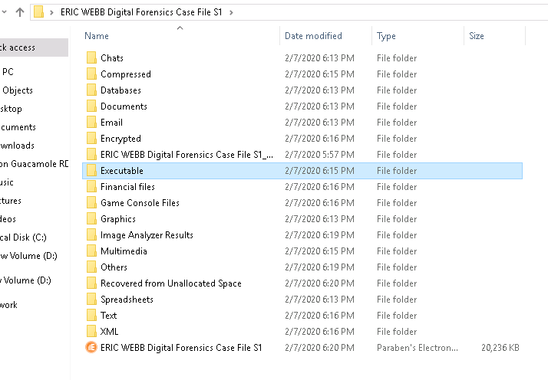

Section 2

Suspect Drive 02 evidence loaded in E3.

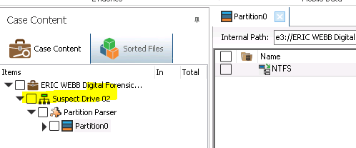

Expanded list of sorted files and number of records. (2623)

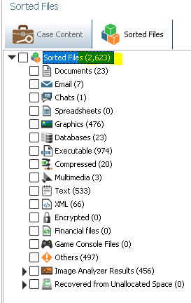

Clean and Suspicious files (110 and 19)

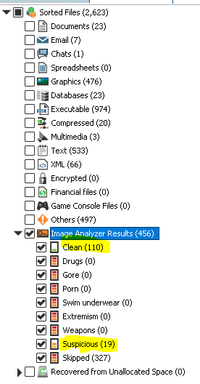

TimeStamp

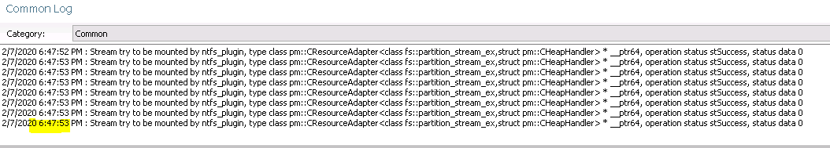



It stored them all in folders by categories rather than in there raw original format.

Section 3 part 1

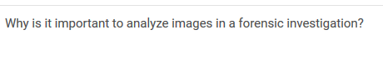

Analyzing images in a forensic investigation saves time and resources and can give a quick detailed analysis without spending the mundane effort and man hours.

Section 3 part 2

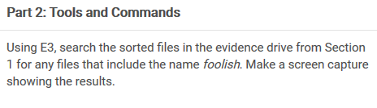

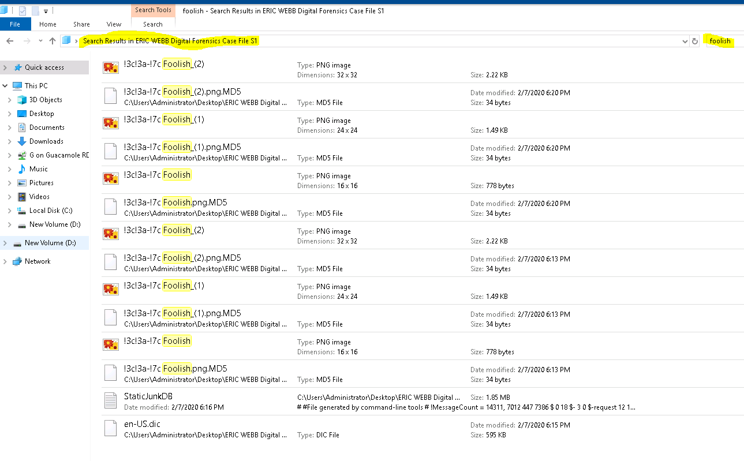

Section 3 part 3

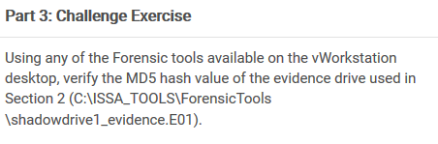

Md5 matches in both FTK and Encase.